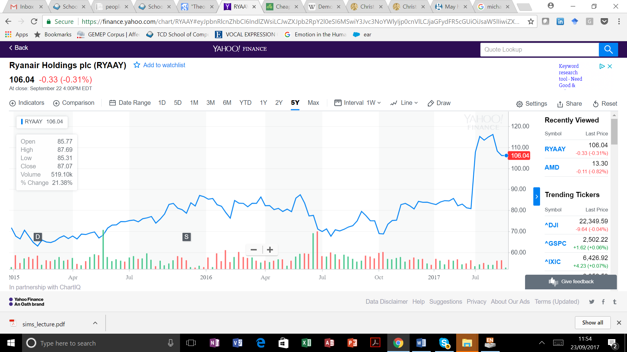

How is the economy affected by unexpected events and changes in economic policy? What effects do interest rate hikes and tax reductions have on the production of good and services, unemployment, inflation and investment? Christopher Sims has developed methods for examining the relationship between policy and economics. For example, he has developed a method for analysing how the economy is affected by increases in the price of oil and how the key interest rates of central banks affect inflation and economic growth.

Christopher Sims, an econometrician, who followed other distinguished economists (Tinbergen, 1939), considered how a (national) economy can be impacted by unexpected events and changes in economic policy. He looked at the interacted and he illustrated this interaction by studying ‘the price of oil and how the key interest rates of central banks affect inflation and economic growth’ ([Sims’ Nobel Prize Introduction, 2011](https://www.nobelprize.org/nobel_prizes/economic-sciences/laureates/2011/sims-facts.html)). Briefly, what we have in Sims’ method is an analysis of a multivariate time series (Sims, 2012) in which independent variables in an equation are used to compute the value of a dependent variable and its linear dependence on these variables. Each independent variable can be used as a dependent variables of all others and a statistical test (Clive Granger’s *causality* test) can be performed to ascertain the significance of the dependence of one variable on the other. Sims’ work dealt with macroeconomic issues and a very large number of variables that may or may not impact a large economy – exchange and interest rates, commodity prices and that of finished goods, inflation rates, and proxies related to shocks. Yet, Sims’ method provided for the inclusion of *sentiment proxies* as both independent and dependent variables of asset prices. Using what is now regarded as *vector autoregression*, we can statistically test whether asset price, at one instance in time, are dependent on market sentiment (proxy), and also test whether the sentiment is dependent on the prices.

SIMS, C. A. 2012. Statistical modeling of monetary policy and its effects. *The American Economic Review,* 102**,** 1187-1205.

TINBERGEN, J. 1939. Statistical Testing of Business Cycle Theories: Part I: A Method and Its Application to Investment Activity.